FEGA Request from submitter to submit to FEGA node
January 2022 - Proposed Version 1.0

Purpose

To create a metadata-only submission account at Central EGA (CEGA) to link to data submitted to a Federated EGA (FEGA) node and outline the communication between the CEGA and FEGA during this process.

Scope

This SOP must be used for the creation of a metadata-only submission account at CEGA for data submission to a FEGA node upon the completion of the FEGA nodes’ Data Processing Agreement (DPA) with the submitter. A sanity check with the credentials generated in the Submitter Portal and the usage of articles throughout this process is also detailed in this SOP.

Procedure

FEGA NODE

- Submitter contacts the FEGA helpdesk requesting to submit to FEGA.
- Submitter obtains information from FEGA node that is required for submission.
- Submitter signs and returns Data Processing Agreement (and any related agreements) to FEGA node.
- FEGA node validates the DPA and asks the submitter to send an email to CEGA Helpdesk (helpdesk@ega-archive.org) to request a metadata submission account.

CEGA

- Submitter contacts the CEGA Helpdesk requesting a submission account.
- CEGA checks that all the necessary details have been supplied by the submitter (i.e. Name, Institution, Acronym, and type of data).
- CEGA emails the relevant FEGA helpdesk to check if a DPA has been signed by this user for a submission to FEGA. Example email:

To: <FEGA node Helpdesk>
Subject: FEGA Submitter account request

Dear FEGA Helpdesk,

I hope this email finds you well, we have received a request from (User email), could we confirm with you that they have signed the DPA and can be assigned a CEGA submission account for metadata submission?

Kind regards,
CEGA Helpdesk

FEGA NODE

- FEGA helpdesk checks if the DPA has been signed and submitted and confirms the names and email addresses of the individuals who are authorised to submit metadata to CEGA.
  - If everything is OK: Reply in email to CEGA helpdesk with a green light and list of authorised submitters (including names and email addresses).
  - If there is an issue: Reply in email to CEGA helpdesk that there is an issue and it is being investigated.

CEGA

- CEGA helpdesk issues a creation of a new fega-(node)-box-### enabled for submission to the correspondent node’s file upload area. For example:
  - Norway: fega-no-box-###
  - Sweden: fega-se-box-###
  - Finland: fega-fi-box-###

Note: FEGA node submission accounts are linked to the node-specific upload areas, NOT to CEGA upload areas. These accounts are named "fega-no-box-##" (e.g. for a Norway box).The creation of the account is for the purpose of enabling metadata submission via the Submitter Portal and must NOT be used to upload data files to CEGA.

- Register the request on the FEGA submission accounts.
- Follow this SOP for the Creation of a Node Submission Account
- Reply to the submitters via RT by using Article ## , reference this ticket number as a comment in the “Submitter account request-FEGA-node” ticket sent by the node.
- Inform on the “Submitter account request-FEGA-node” Ticket to the FEGA that the account has been created and resolve the ticket.

Dear FEGA <node> Helpdesk,

We hope this email reaches you well. We would like to inform you that the following submission account (fega-(node)-box-####) has been created for the user (user email) and all instructions for metadata submission have been shared with them.

We will now resolve this ticket. Please reopen this ticket when you require the metadata verification.

Please let us know if you have any questions,

Kind regards,
CEGA Helpdesk

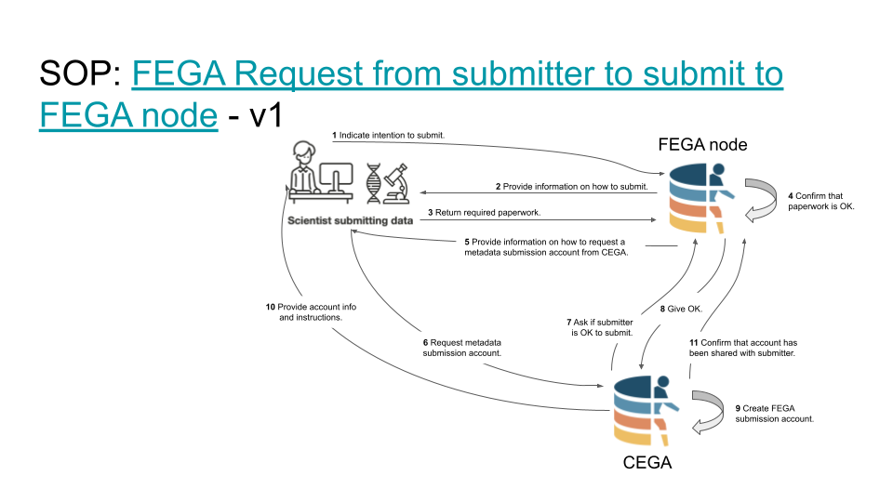
Future improvements/ideas

- For “request a metadata submission account.”, draft a template email that all nodes can share with their submitter to send to CEGA.
- Simplify emails comms as described in this protocol (https://docs.google.com/document/d/1-1iHy1eMPX2A6liXs6bjuWg1FBGOxFtqXcNwyOYwZZg/edit) and illustrated in this diagram (https://docs.google.com/presentation/d/1S6eFVEfXH0YVBSc-8RWRAsfxsyqyQspFf3rOp6u_WDY/edit#slide=id.g10d68a1d910_0_0).

